**How to get a FinCEN ID**

1. Go to <https://secure.login.gov/>
2. Select Create an account
   1. Enter Email Address
   2. Select language
   3. Click read and accept
   4. Click Submit button

1. An email will be sent to the email address you entered to verify the address so you will need to go to your email inbox and confirm the email address.
2. After clicking the confirm button in your email you will be asked to create a password.
3. Set up authentication method
4. Select one of these options and follow instructions to set up authentication.

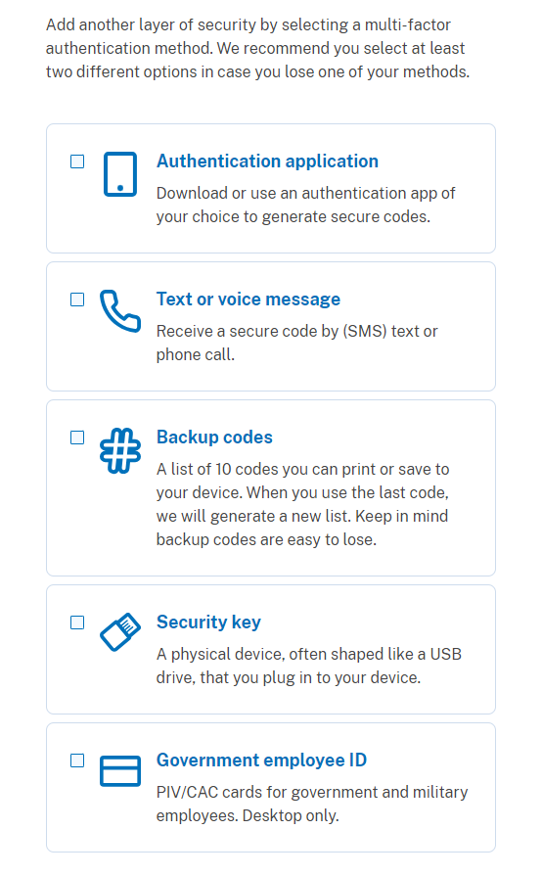

1. Once you have created an account you can then proceed to apply for the FinCEN ID

**FinCEN Identifier (FinCEN ID) Application**

[**https://fincenid.fincen.gov**](https://fincenid.fincen.gov)

1. Name
2. Address
3. Identifying document type – You can choose one of the following and you will need to upload a copy.
   1. State-issued driver’s license
   2. State/local/Tribe-issued ID
   3. US Passport
   4. Foreign Passport
4. Click I agree to certify that the information provided is true
5. Click Submit button
6. A FinCEN ID will be immediately issued
7. Download and print the document.