How to File your Beneficial Ownership Information Report
- Go to https://boiefiling.fincen.gov/
- Click on the Get Started button
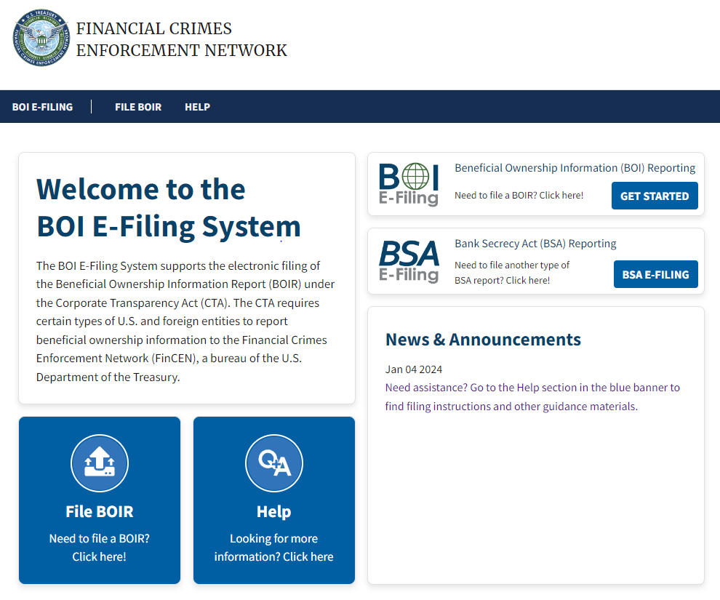
- Click on Prepare & Submit BOIR
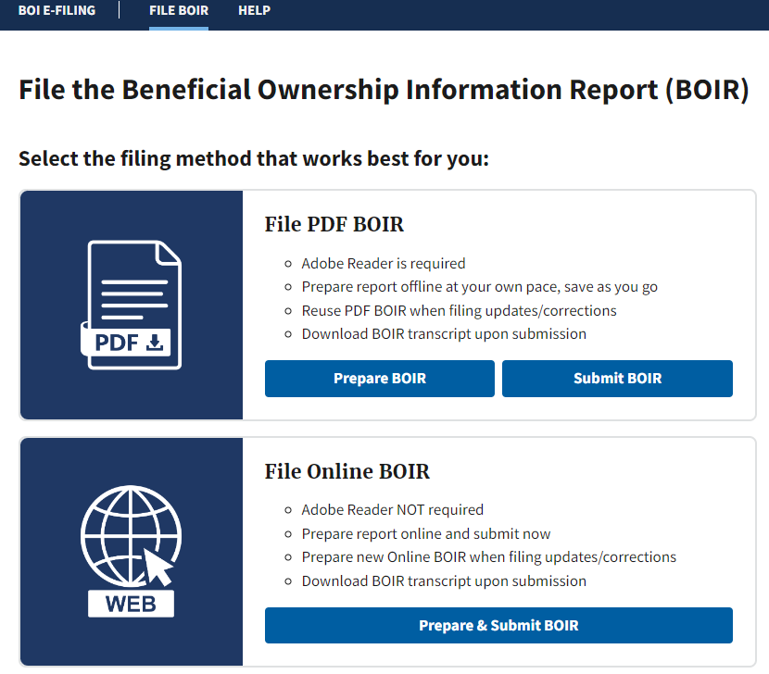

- Select Initial Report
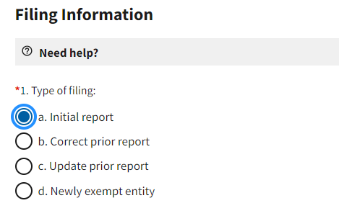
- Select request to receive FinCEN ID
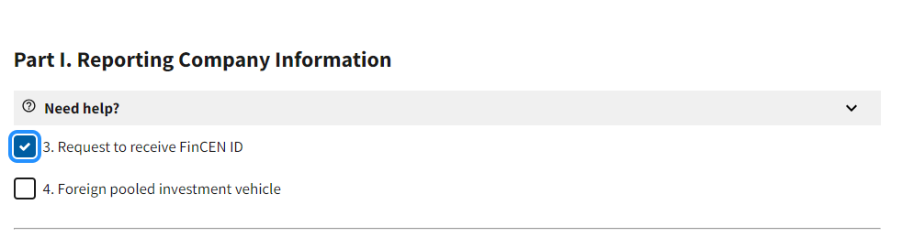

- Tax Identification Type
  - If you are filling out for a C Corp, S Corp, LLC or Partnership then you will enter the EIN.
  - If you are filling out for a Single Member LLC and you do not have an EIN then you will use the SSN of the Single Member.

- Check the 16. Box if your company was in existence before 01/01/2024.
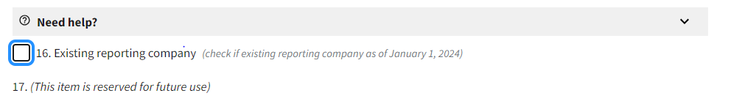

- Part II. Company Applicant Information: Fill out if your entity was started in 2024
  - If you have a FinCEN ID for each partner/member/shareholder then that is all you will need to enter.
  - If you do not have a FinCEN ID then you will need to have the following information for each individual:
    - Name
    - Date of Birth
    - Address
    - Identifying Documentation such as driver's license or passport
    - Upload copy of identifying documentation

- Part III. Beneficial Owner Information:
  - If you have a FinCEN ID for each partner/member/shareholder then that is all you will need to enter.
  - If you do not have a FinCEN ID then you will need to have the following information for each individual:
    - Name
    - Date of Birth
    - Address
    - Identifying Documentation such as driver's license or passport
    - Upload copy of identifying documentation

